Our vision is to make original contemporary African choreography that excites, transforms and enriches people's experience of dance.
Through performance, training, learning and participation, we aim to share a culture of creative exchange, opportunity, excellence and innovation.

Learning and Participation Workshops 2016-2017
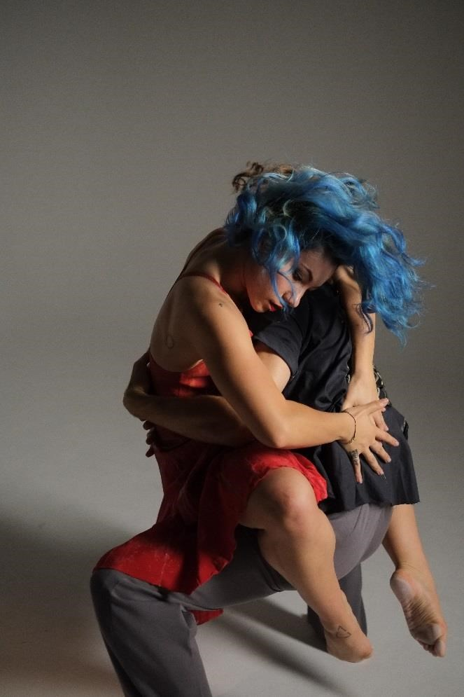

Tavaziva’s Africarmen is a sumptuous and evocative dance production loosely based on George Bizet’s popular opera Carmen.
Through a synthesis of ballet, contemporary and African dance, Bawren Tavaziva’s powerful choreography is performed by a cast of outstanding dancers.
Played out through the entanglement of desire, deceit and corruption in a township of oil-laden Equatorial Guinea, lingering ancestral voices are at work here amongst the dreams of a better life.
With a new score composed by Fayyaz Virji of the acclaimed Warriors International, Africarmen is Bawren Tavaziva’s most ambitious work to date.

Africarmen tours UK theatres from March 2017
For dates visit www.tavazivadance.com
Workshops
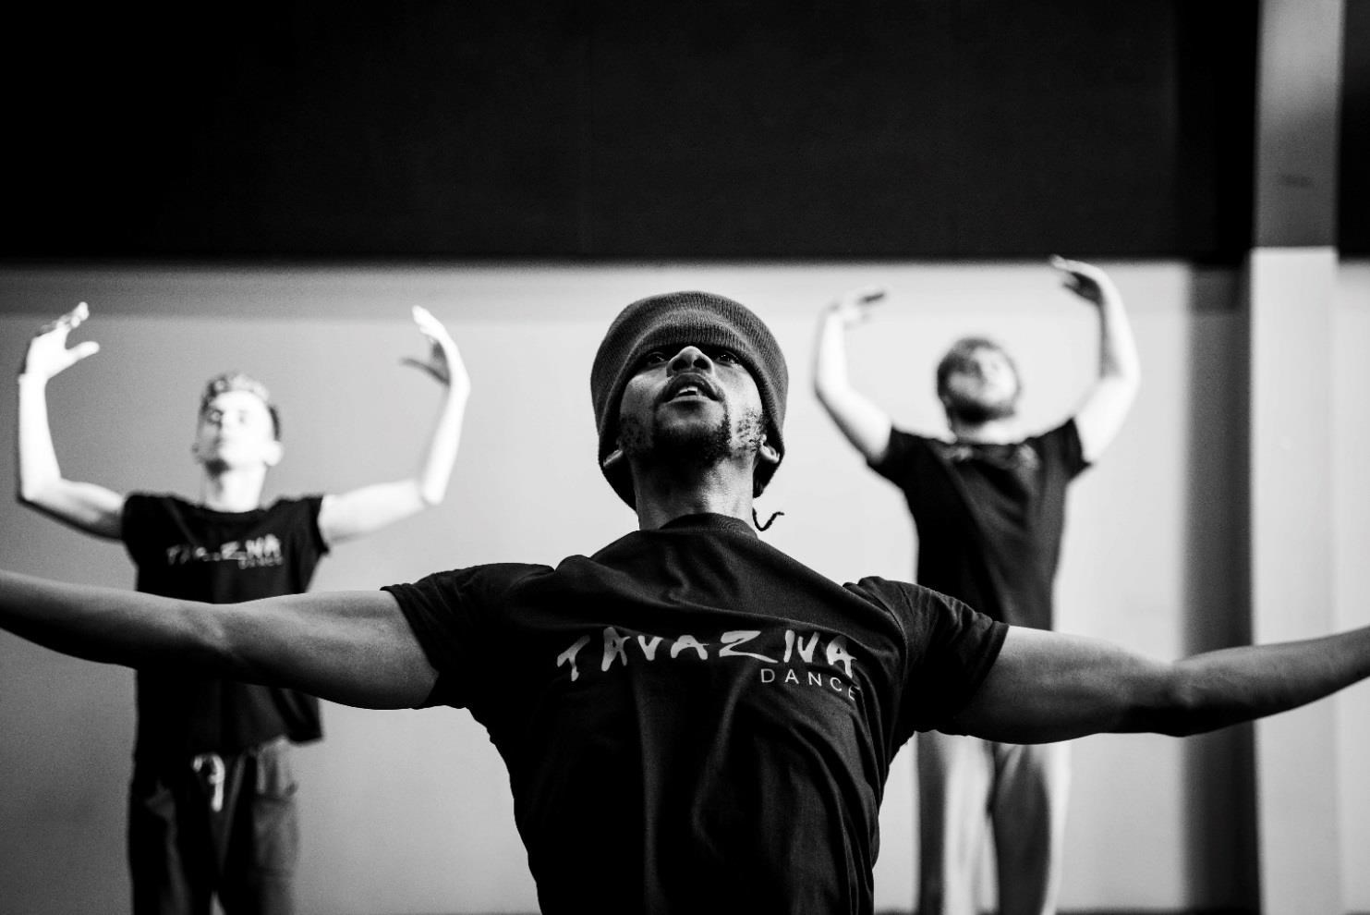

Taking part in a TAVAZIVA workshop is the perfect accompaniment to seeing Africarmen live.

Bawren Tavaziva’s highly inventive choreography is a synthesis of ballet, contemporary and
African dance and is energetic, intricate and physically challenging. Tavaziva deliver workshops for professional dancers, dance students, school and community groups.
TAVAZIVA WORKSHOPS AIM TO:

- Challenge and expand participants physical, creative and technical dance range
- Enhance young people’s engagement with the production ‘Africarmen’ - providing a memorable and enriching experience
- Deepen understanding of the themes, story line, characters and vision for the work
- Discover, share and gain insight into different cultures
- Engage young people into dance and the arts
- Widen access to contemporary dance and encourage new audiences to the theatre

“Great, approachable, down to earth and friendly dancers … excellent role models to follow, especially for the boys” -College Teacher, 2014

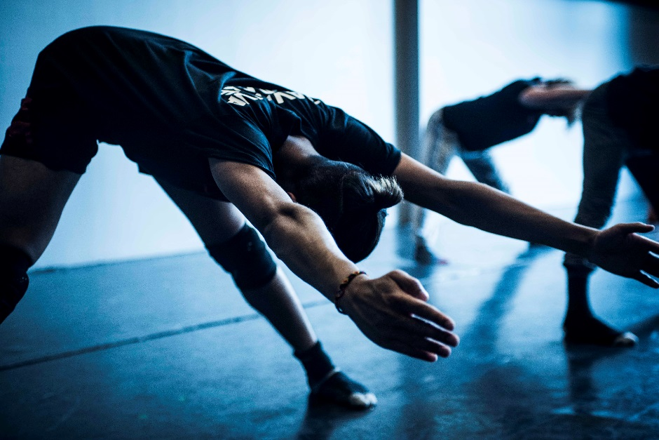

Workshop Programme

REPERTOIRE and CREATIVE WORKSHOPS

Participants will delve in to the world of ‘Africarmen’ by learning repertoire from the production and will use this to develop their own choreography. They will share the material created, gaining performance skills and building confidence. These workshops offer a real insight into the way Artistic Director Bawren Tavaziva choreographs and are ideal for dancers of all abilities as well as dance students who are creating their own work.

2 hours: £250 / Full day: £400

CHOREOGRAPHIC RESIDENCIES and CURTAIN RAISERS

Using Tavaziva repertoire as a starting point, participants will work with the company to develop their own performance piece. The work created is of high quality and aims to achieve the same production values as Tavaziva’s company work. This can culminate in a performance of a curtain raiser at one of our touring venues to open the production, Africarmen. These curtain raisers have always proved a highly rewarding, memorable and unique performance opportunity for the group.

2 day residency: £700 / 3 day residency: £1000

Things to know
- Workshops can be tailored to curriculum programmes and are particularly beneficial for GCSE and A-level groups
- Workshops will cover themes including love, deceit, jealousy, tragedy, fear and vulnerability, and power
- Workshops are led by Artistic Director Bawren Tavaziva and our Company of dance artists
- All workshop leaders are DBS checked

Workshops outside of London
- Travel and accommodation costs may be required
- A higher workshop rate may be applicable
Booking
For more information or to book a workshop please contact Tavaziva’s Learning and Participation Manager:
Kathleen Murphy
Learning and Participation Manager

E: kathleen.murphy@tavazivadance.com
T: 0208 365 9150
W: www.tavazivadance.com

‘What counts is what they do and how amazingly well they do it’
– The Times
About Tavaziva
Tavaziva Dance is one of the UK’s leading contemporary-African touring dance companies and was established in 2004. Led by Zimbabwean-born Bawren Tavaziva, the company creates and tours original new productions that portray challenging and current topics rooted in African cultures.
Tavaziva Dance is now a National Portfolio Organisation (since 2011) with six exceptional and versatile dancers, many of whom have worked and developed with the company over several years. Last year Tavaziva Dance celebrated their ten year anniversary.
With Tavaziva Dance, Bawren Tavaziva has created a distinctive contemporary style that is evocative, memorable and highly inventive. His music composition and unique choreographic language have been described by the press as ‘Nothing short of explosive!’ - The Stage.

Artistic Director - Bawren Tavaziva

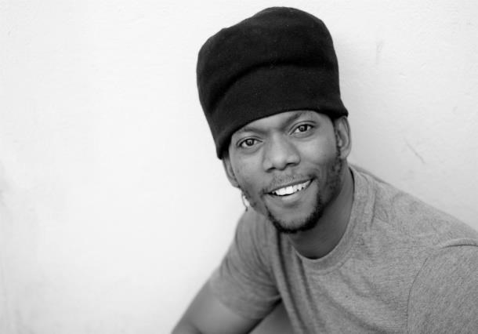
‘Bawren Tavaziva has established himself as a dominant talent within the African dance diaspora, as well as a significant voice within the British dance scene.’
- The Guardian

Bawren Tavaziva was born in a rural village near Masvingo in Zimbabwe. Football, Michael Jackson, New Edition and Kung Fu movies viewed at the local community hall provided inspiration to Bawren and his friends. Bawren's musical talents also developed at this time on a guitar made by his brother from a 5 litre tin can and fishing wire.

At the age of 12 Bawren Tavaziva attended an outreach ballet project with the National Ballet of Zimbabwe at his local community centre. From day one, his determination and talent led him to a lifelong passion for dance. He danced with Tumbuka for five years and toured Africa. He came to England to join Phoenix and Union dance and in 2004 he presented his own choreography and music as a finalist at The Place Prize with a deeply moving quintet entitled Umdhlalo Kasisi, in memory of his sister who sadly died of HIV.

After this, Bawren formed his own company and became Artistic Director of Tavaziva Dance. He produced Umdlalo Kasisi 2004, Soul Inspired 2005, Bophelo 2006, Chatsva 2007, Heart of Darkness 2009, Wild Dog 2010, Double Take 2011, Sensual Africa 2012, Greed 2013 and in 2014 celebrated the Company’s 10 year anniversary with a national tour of Tavaziva Ten.
Africarmen, created in 2015, is Bawren’s latest and most ambitious work, created with an expert team of distinguished collaborators including Composer Fayyaz Virji, Writer and Dramaturge Chris Fogg, Creative Advisor Neville Campbell, Set Designer Joseph Bisat Marshall, Costume Designer Ben Voorhaar, Lighting Designer Sherry Coenen and Creative Producer Beth Cinamon.

“It’s very important in life to work with young people, because I was given the opportunity to dance when I was young and that changed my life. I want to inspire young people”
Bawren Tavaziva

